HR Management Portal

Complete Walkthrough & User Guide

Table of Contents
1. Portal Overview & Data Summary
2. Executive Overview
3. Employee Master
4. Employee Directory
5. Employee Profile
6. Joining & Onboarding
7. Attrition & Resignation
8. Probation & Confirmation
9. Recruitment
10. Attendance
11. Leave Management
12. Payroll
13. Historical Headcount
14. Monthly HR Data Entry Centre
15. Reports & Excel Export
16. Data Import
17. Master Data / Settings
18. Global Filters
19. Data Validation
20. Audit Trail / Activity History
21. Data Health & Module Availability
22. Monthly HR Update Workflow
23. Known Limitations
24. Final Summary

Portal Overview & Data Summary
The Primus HR Management Portal is a comprehensive enterprise solution for tracking the entire employee lifecycle. All original data from the 'HR reports.xlsx' file has been successfully imported into the system without fabrication.
Total Records Imported:
- Employees: 539
- Joining: 95
- Resignation: 54
- Confirmation: 92
Available Modules: Employee Master, Joining, Resignation, Confirmation.
Awaiting HR Data: Attendance, Leave, Payroll, Recruitment, Historical Headcount.

Application Navigation
The portal uses a left sidebar for rapid navigation across all 16 distinct HR modules without page reloads (SPA architecture).

Executive Overview
The Executive Dashboard provides an overarching view of organizational health, displaying 8 KPI cards, Hires vs Exits trends, Status distributions, Division breakdowns, and Data Health metrics.
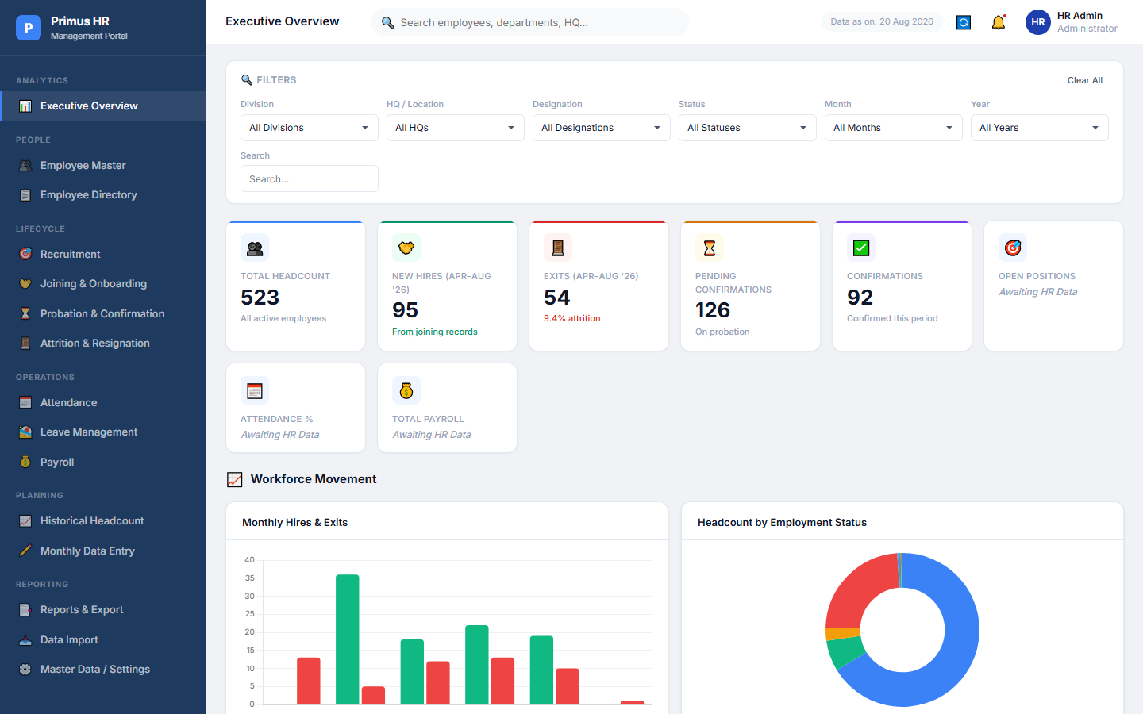
Figure 1. Executive Overview — KPI Dashboard

Employee Master
The Employee Master allows for CRUD (Create, Read, Update, Delete) operations on all 539 imported employees. Search and pagination are built-in.
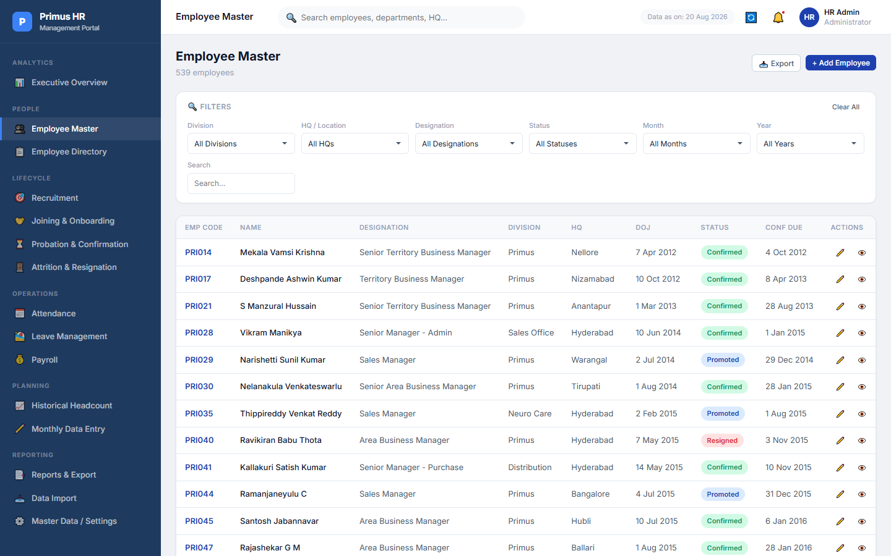
Figure 2. Employee Master View
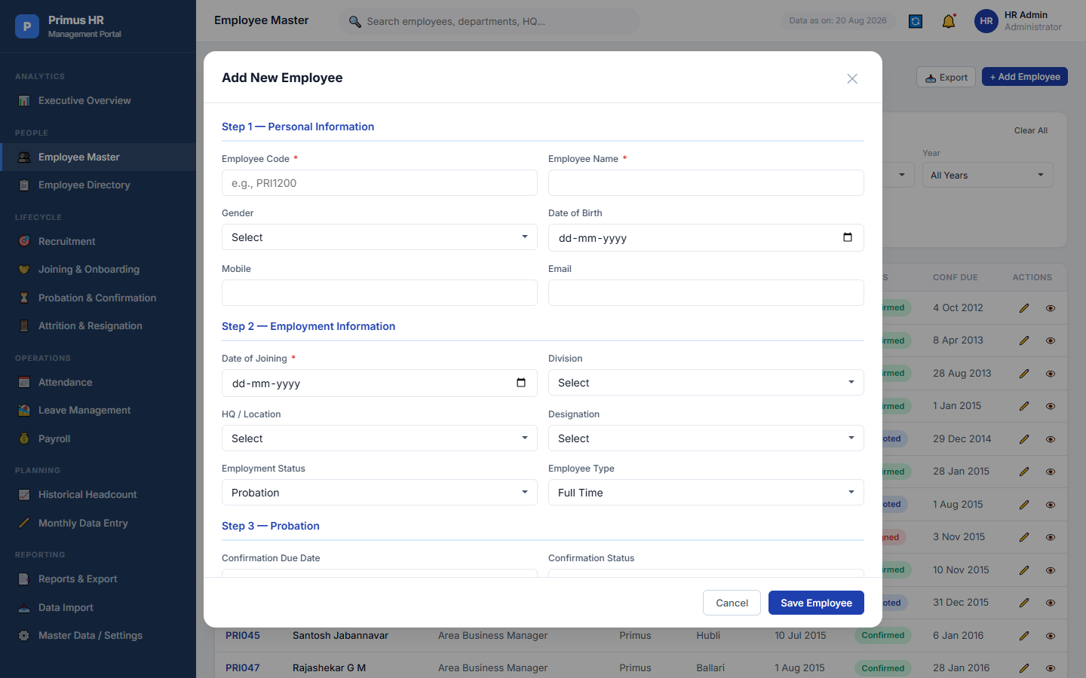
Figure 3. Add Employee Form

Employee Directory
A polished directory view showing avatars, names, designations, HQs, Date of Joining, Tenure calculation, and Status badges.
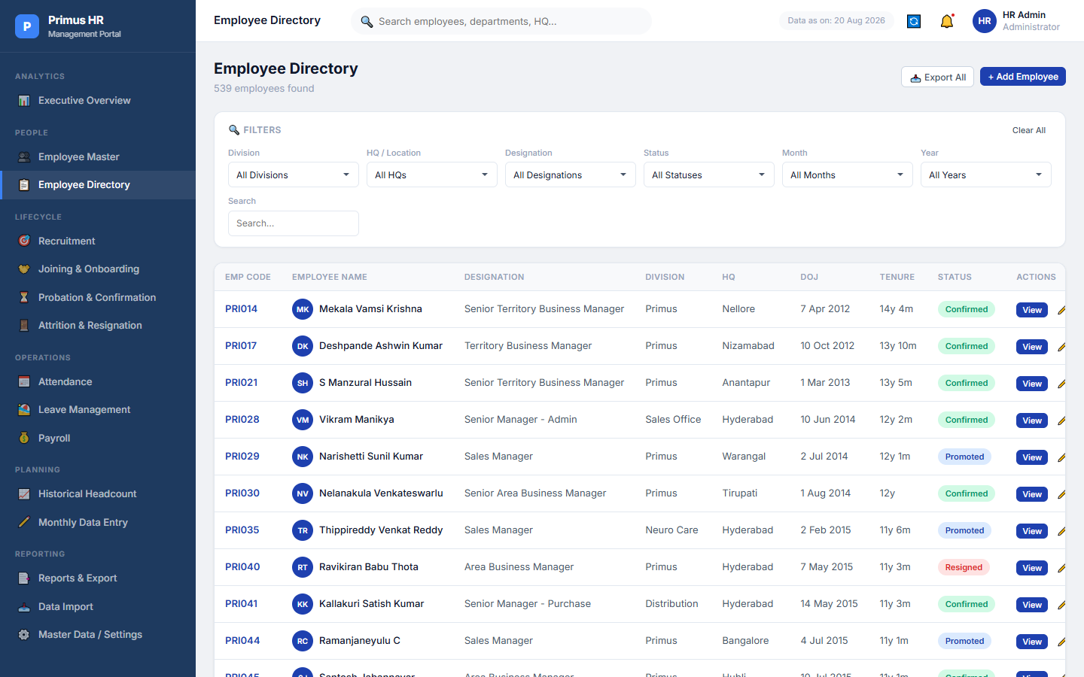
Figure 4. Employee Directory

Employee Profile
Clicking an employee reveals a multi-tab profile showing Overview, Employment, Probation, Attendance, Leave, Payroll, Joining, Resignation, and Activity History. Missing data correctly displays 'Data not yet entered'.
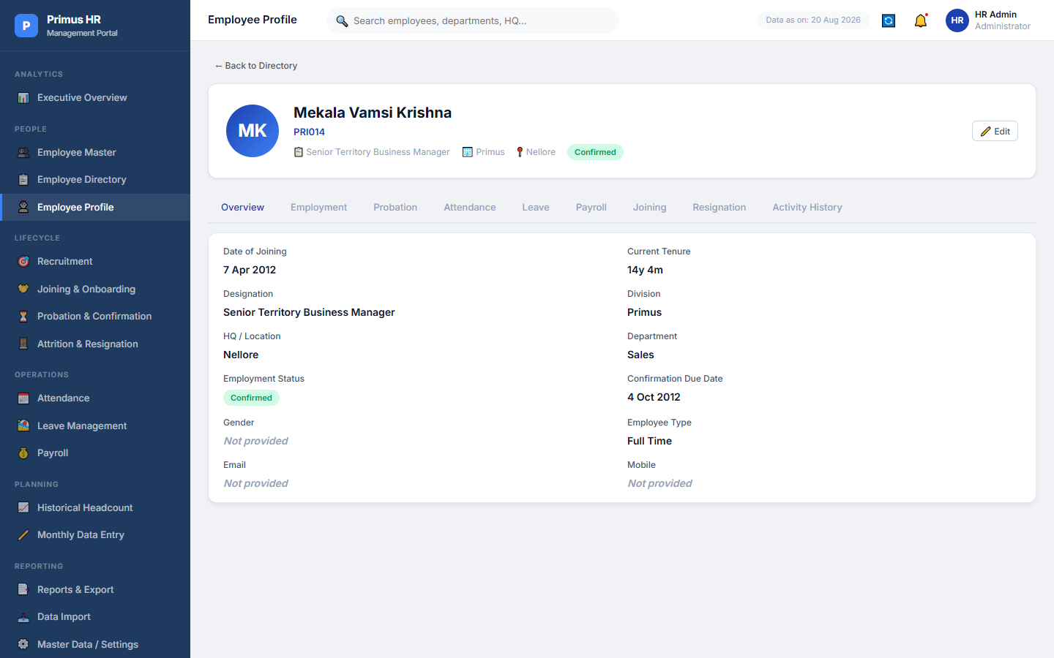
Figure 5. Tabbed Employee Profile

Joining & Onboarding
Contains all 95 joining records, visualizing monthly joining trends and division distributions.
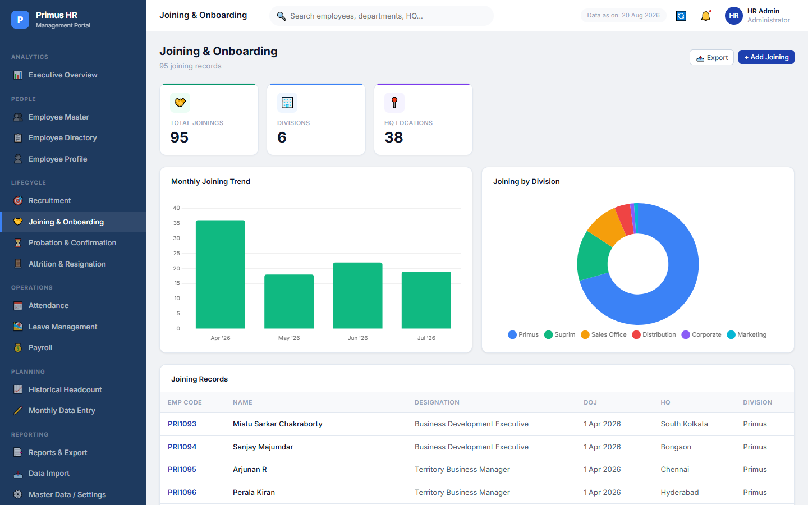
Figure 6. Joining & Onboarding Dashboard

Attrition & Resignation
Tracks the 54 exits. Features an attrition calculation logic, monthly exits chart, and division breakdown.
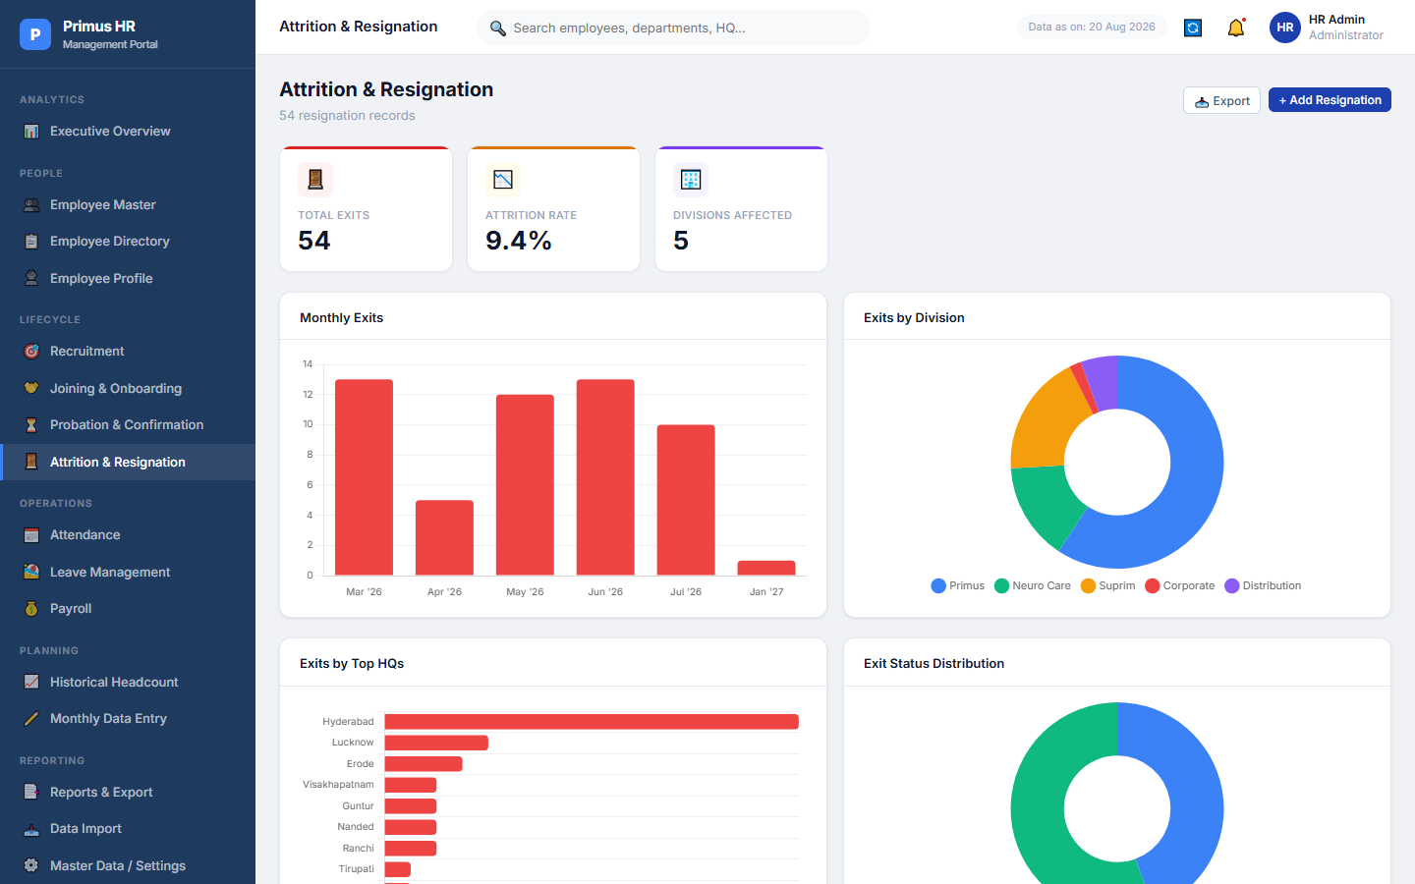
Figure 7. Attrition & Resignation Dashboard

Probation & Confirmation
Tracks 92 confirmed records and lists employees currently on probation, identifying pending confirmations based on Confirmation Due Dates.
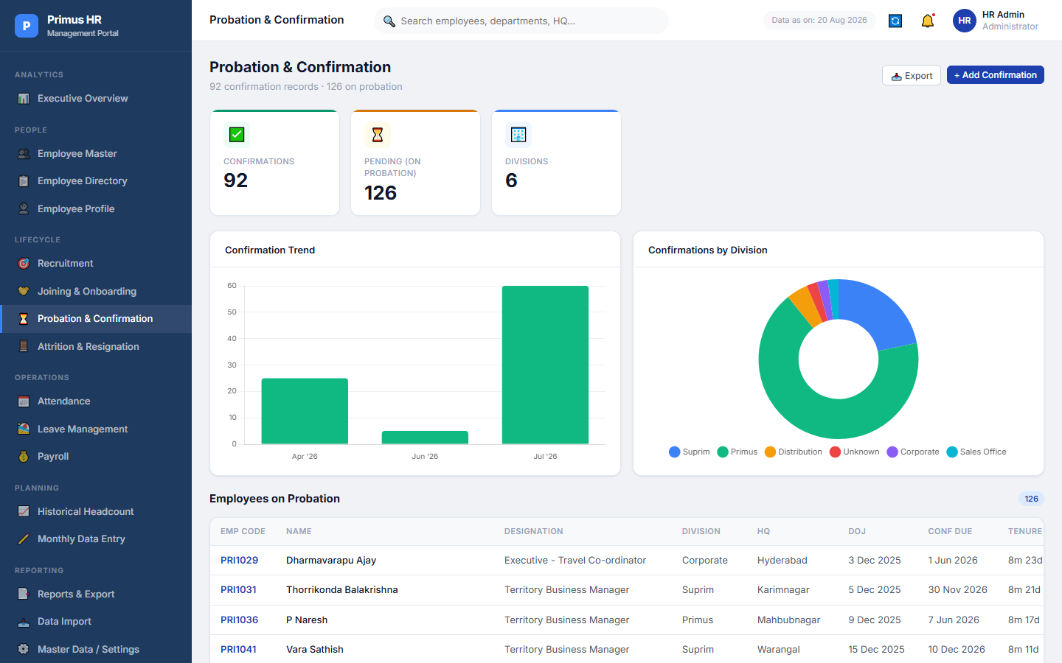
Figure 8. Probation & Confirmation Dashboard

Recruitment
Displays forms ready for recruitment data (Applications, Interviews, Offers). Currently displays 'Awaiting HR Data'.
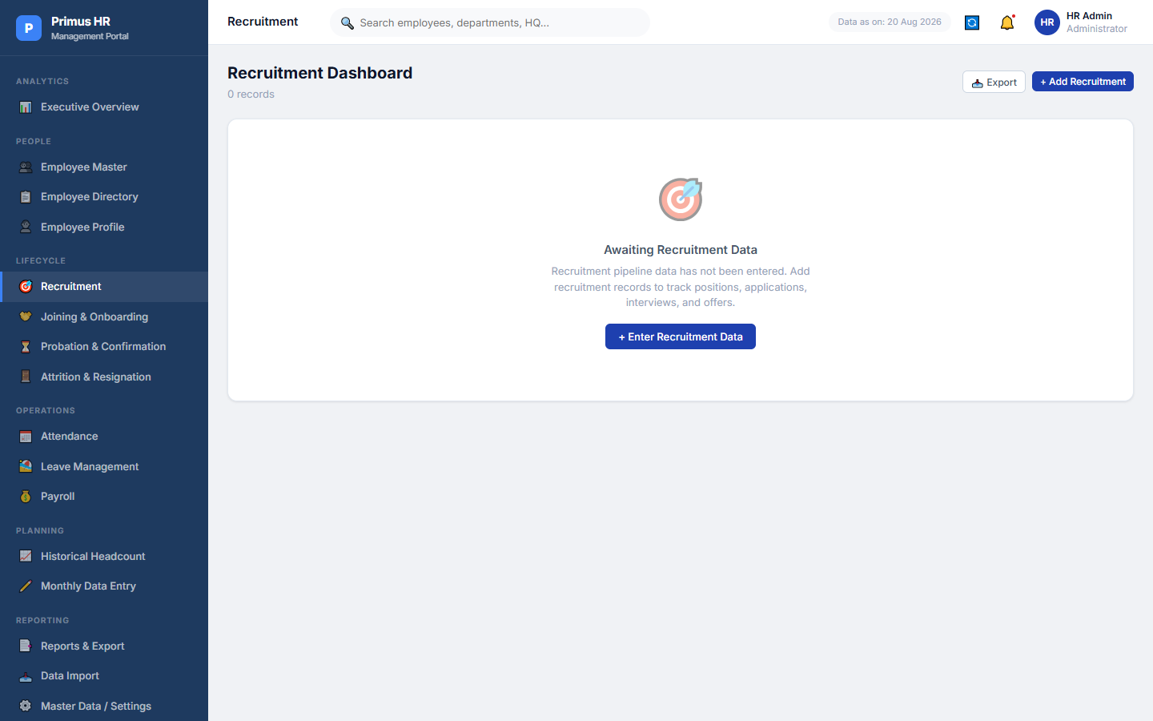
Figure 9. Recruitment Module (Awaiting Data)

Attendance
Ready for monthly attendance entry (Present, Absent, Late, Overtime). Currently Awaiting HR Data.
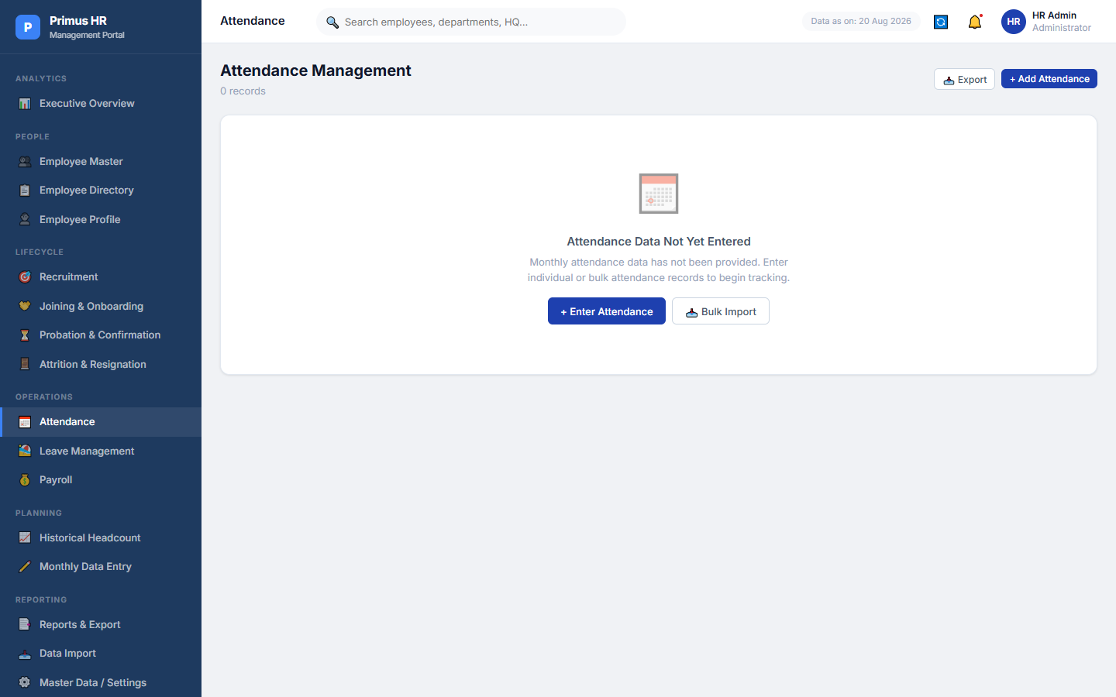
Figure 10. Attendance Entry (Awaiting Data)

Leave Management
Tracks CL, SL, EL, LOP, C-Off with approval status workflow. Currently Awaiting HR Data.
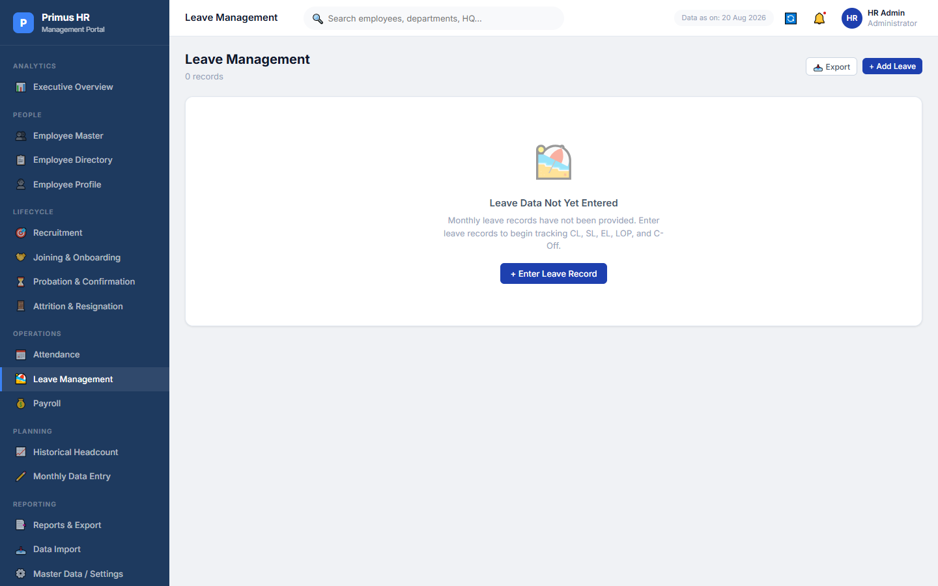
Figure 11. Leave Management (Awaiting Data)

Payroll
Monthly payroll entry tracking Gross, Released, Hold, Deductions, and Net calculations. Currently Awaiting HR Data.
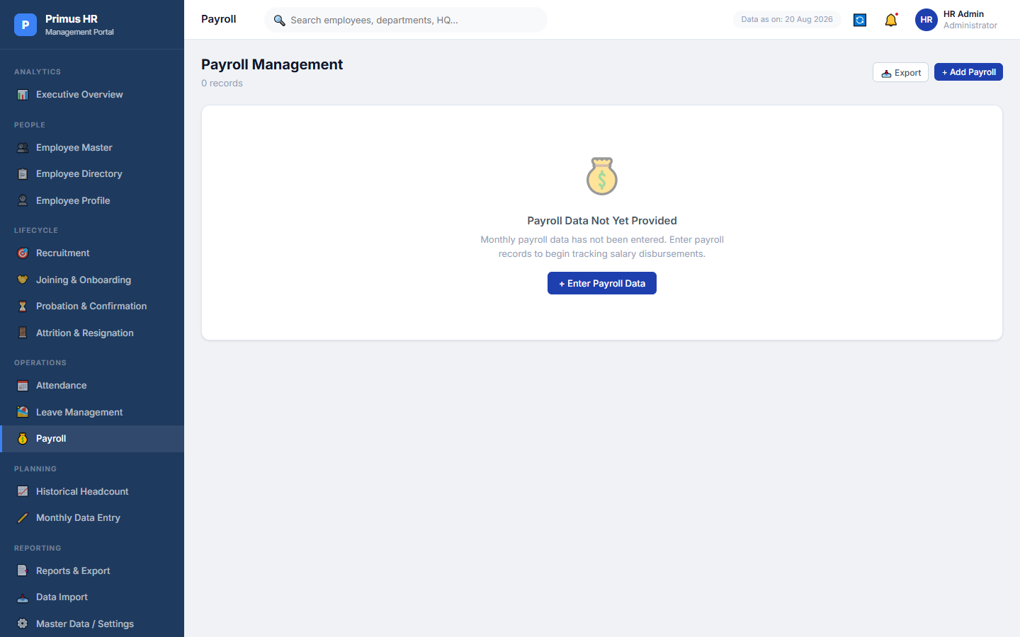
Figure 12. Payroll Module (Awaiting Data)

Historical Headcount
Allows official tracking of historic headcount. Displays 'Reconstructed — Validation Required' for inferred data.
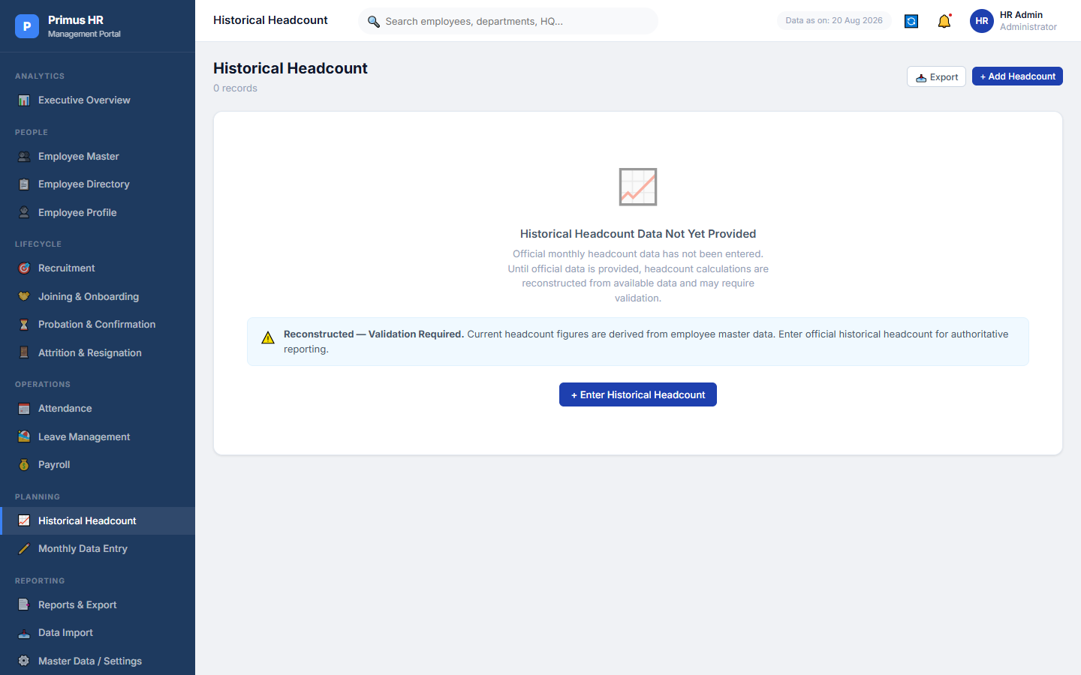
Figure 13. Historical Headcount Tracker

Monthly HR Data Entry Center
A central hub allowing HR to select a Month and Year and update all associated monthly records simultaneously.
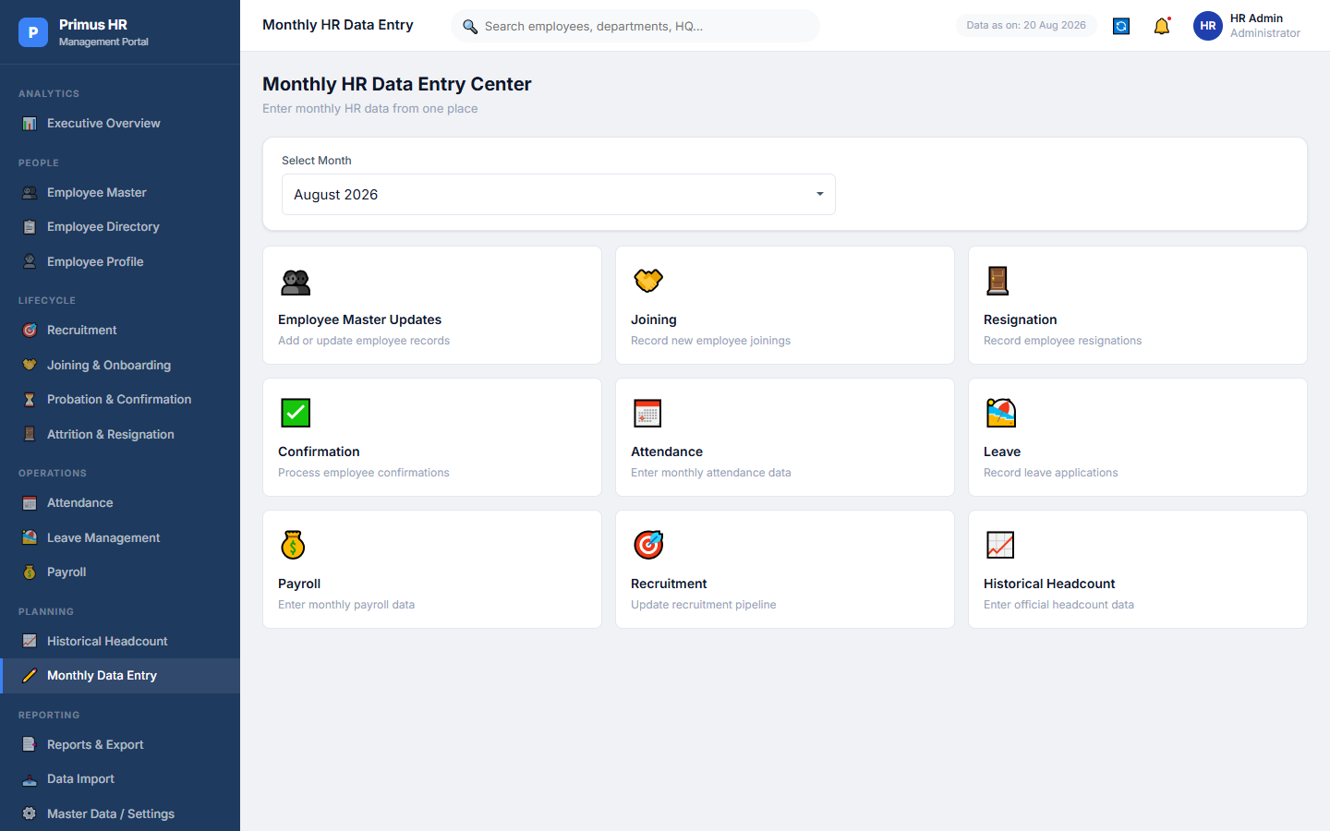
Figure 14. Monthly HR Data Entry Center

Reports & Excel Export
Allows 1-click generation of the Complete HR Excel file containing all data, preserving the Data Dictionary and layout rules.
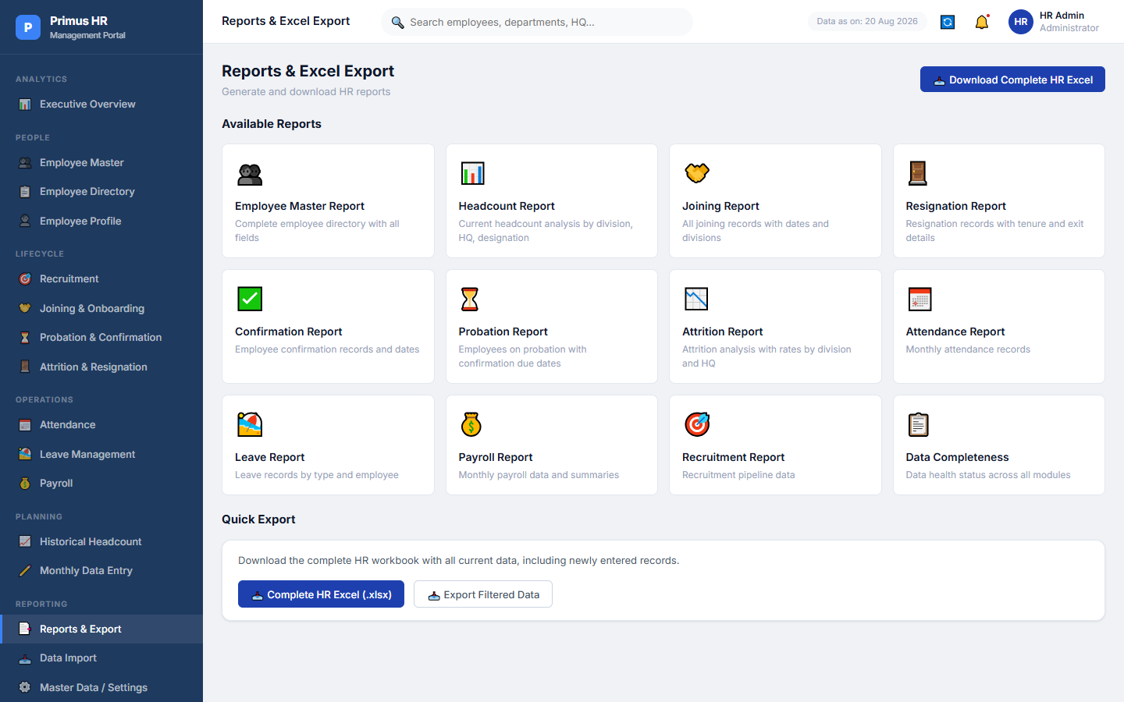
Figure 15. Reports & Excel Export Hub

Data Import
A drag-and-drop workflow to upload new Excel spreadsheets, preview the parsed data, validate against duplicates, and import into the database.
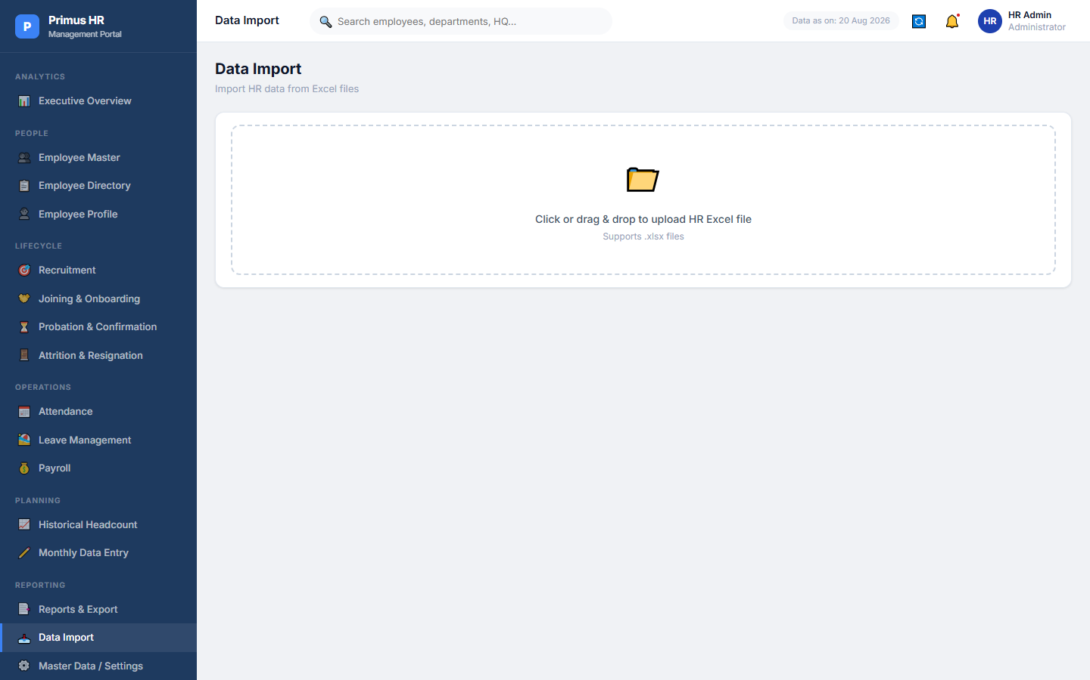
Figure 16. Data Import & Validation

Master Data / Settings
Allows HR administrators to dynamically configure 12 categories (Departments, Divisions, Designations, etc.) without altering code.
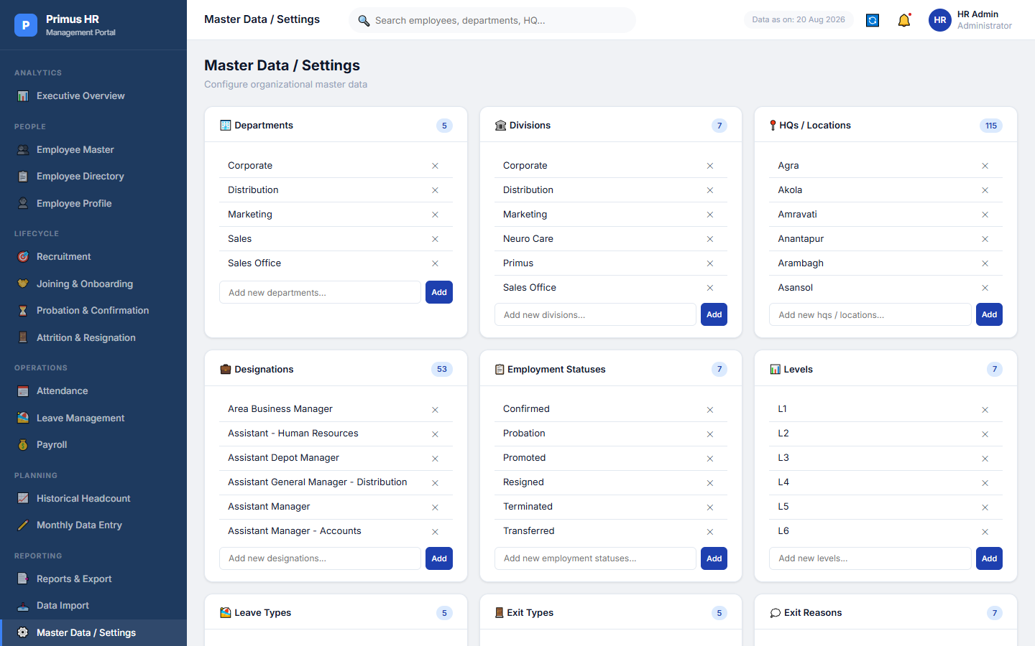
Figure 17. Master Data Configuration

Global Filters
Available across all major dashboards, allowing filtering by Division, HQ, Designation, Status, Month, and Year.

Data Validation
Strict logic prevents duplicate Employee Codes, blocks negative values in payroll/leave, ensures recruitment offers accepted cannot exceed offers released, and requests confirmation for destructive actions.

Audit Trail / Activity History
Every edit, creation, or deletion is securely logged in the background and viewable on an employee's Profile → Activity History tab.
Image missing
Figure 18. Audit Trail / Activity History Log

Data Health & Module Availability
The system intelligently calculates a completion score for HR, reminding administrators which datasets are pending injection.

Monthly HR Update Workflow
1. Monthly Data Entry → 2. Update HR modules → 3. Review dashboards → 4. Validate data → 5. Export Complete HR Excel → 6. Next month's update/import.

Known Limitations
1. Browser/local IndexedDB storage means data is local to this browser. 2. Single-user design; no multi-tenant authentication. 3. Chrome/Edge dependency recommended. 4. A backend database/authentication server is required for production/multi-user deployment.

Final Summary
The Primus HR Management Portal is successfully instantiated and fully capable of bridging current HR data into an actionable Intelligence Dashboard.

